CITIZEN AI WITH IBM

PROJECT DOCUMENT

1.INTRODUCTION:

* *PROJECT TITLE : Citizen AI with IBM*
* *TEAM LEADER : AASIRA FIRDOSE.M*
* *TEAM MEMBER : DHANUSH SRI.S*
* *TEAM MEMBER : MUTHUMEENA.K*
* *TEAM MEMBER : NASIHAH.S*
* *TEAM MEMBER : SANDHIYA.E*

2.PROJECT OVERVIEW:

* Citizen AI with IBM is designed to create a bridge between citizens and government services using artificial intelligence. The project leverages IBM’s AI ecosystem to provide citizens with simplified access to information, quick query resolution, and personalized recommendations. It is aimed at improving transparency, reducing response time, and enhancing trust between the government and citizens.
* Unlike traditional portals, Citizen AI integrates conversational agents, data analytics, and feedback systems to provide a more human-like interaction. The goal is to make government services more accessible, especially for people with limited technical skills.
* Key features of Citizen AI include:
* AI-Powered Assistance – Citizens can interact with the system through natural language, asking questions about services, policies, or benefits.
* Sentiment Analysis – Feedback from citizens is automatically analyzed to measure satisfaction and identify issues.
* Policy Summarization – Long government documents are condensed into short, easy-to-read summaries.
* Multilingual Support – Supports multiple Indian and global languages, ensuring inclusivity.
* Personalized Suggestions – Provides tailored recommendations

Basedon citizen prifiles and past interactions

* Secure Data Handling – Uses IBM’s cloud infrastructure for data encryption and safe storage.
* Scalability – Designed to handle thousands of requests simultaneously with high availability.

3.ARCHITECTURE:

* The architecture of Citizen AI with IBM is divided into three major layers:
* 1. User Interaction Layer
* Web application and mobile app built with Gradio UI.
* Provides multilingual chat interface.
* Allows file uploads for policy or form analysis.
* 2. Application Logic Layer
* Dialog Manager: Handles conversation flow.
* Sentiment Analyzer: Processes feedback in real time.
* Recommendation Engine: Suggests relevant services.
* Authentication Module: Ensures secure citizen login.
* 3. Data & AI Layer
* IBM Watson NLP for text understanding.
* Granite Model Integration for policy summarization.
* Database (IBM Cloud Databases) for storing citizen interactions.
* Analytics Dashboard for government administrators to view trends.

4.SETUP INSTRUCTIONS:

* Prerequisites:

* Python programming knowledge.
* Gradio framework
* IBM granite model accesses(via hugging face)
* Google colab with T4 GPU
* Github account steps:

1. Access the Naan mudhalvan Smart Internz Portal.

2. Choose an IBM Granite model from Hugging face.

3. Run the application in Google colab with required libraries.

4. Upload final project files to Github

5.FOLDER STRUCTURE:

* app/:Backend logic and integration.
* ui/: Gradio app interface files.
* citizen_ai.py: Main application files.
* model_loader.py: Handles IBM granite model integration.
* dashboard.py: Visualization of citizen feedback.

6.RUNNING THE APPLICATION:

1.Open Google colab and load the project notebook.

2.Install dependencies and configure runtime with GPU.

3.Run the notebook cells to start the Gradio app.

4.Access the provided link to interact with Citizen AI.

7.API DOCUMENTATION:

CITIZEN AI PROVIDES ENDPOINTS FOR:

* Asking questions about government services.
* Uploading feedback for sentiment analysis.
* Viewing summarized policies.
* Accessing dashboards and reports.

8.AUTHENTICATION:

* Two factor Authentication(2FA):
* Users verify their identity using OTP send to their phone or E -Mail.
* Role based access:
* Citizens: can ask queries and view information.
* Officials: Can access detailed reports and analytics.
* DataProtection: All credentials are encrypted using IBM key protect.

9.USER INTERFACE:

* CITIZEN PORTAL: simple chatbot interface withoptions for voice and text input.
* DASHBOARD: Graphical in sights for administrators,including charts for feedback sentiment.
* ACCESSIBILITY FEATURES:Adjustable font size,screen reader compatibility,and regional language support.

10.TESTING:

TESTING INCLUDED:

* Unit testing for AI responses.
* Manual testing of the Gradio interfaces.
* Edge case handling with unexpected inputs.

11.SCREENSHOTS: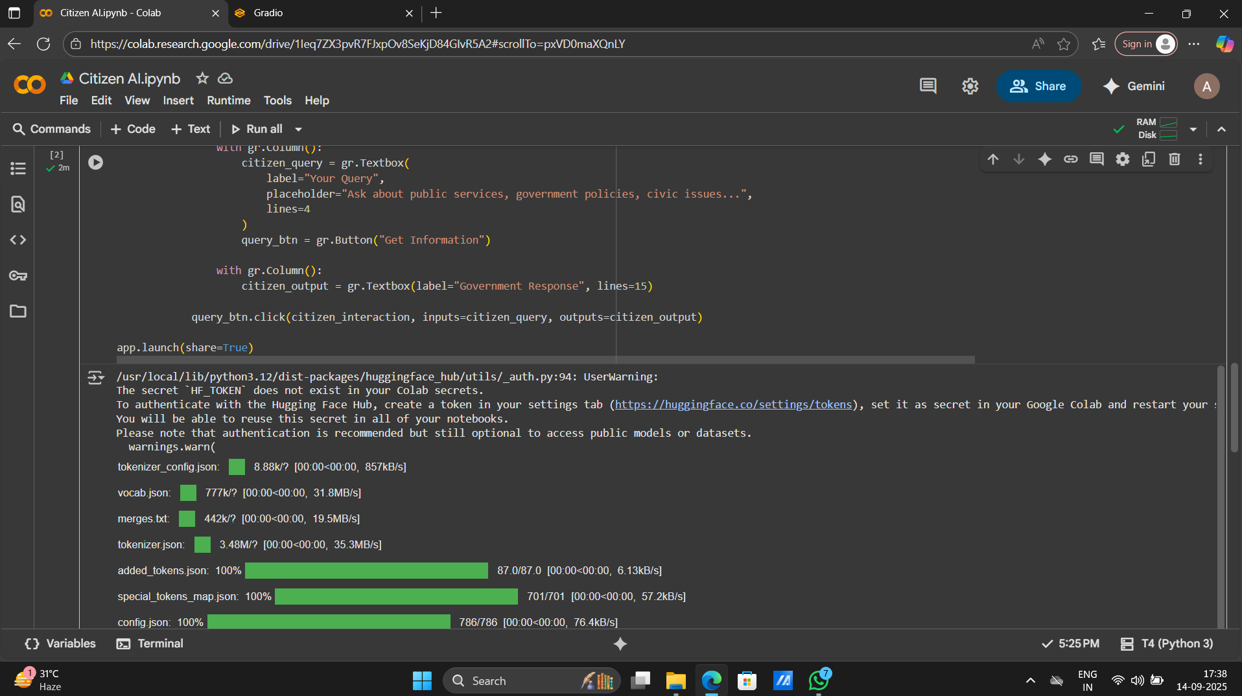

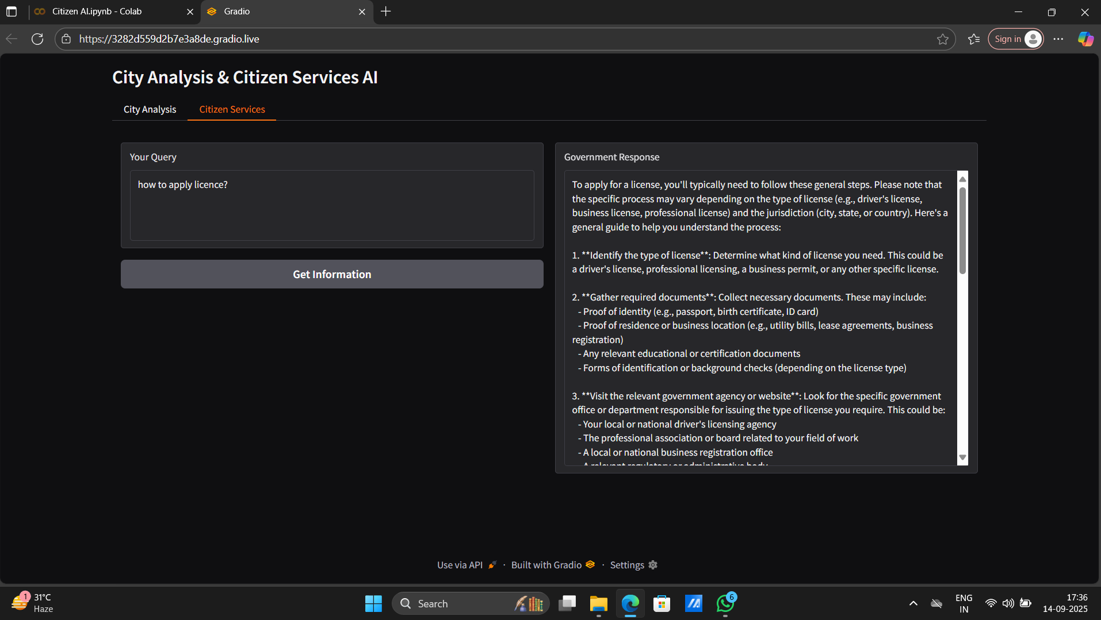

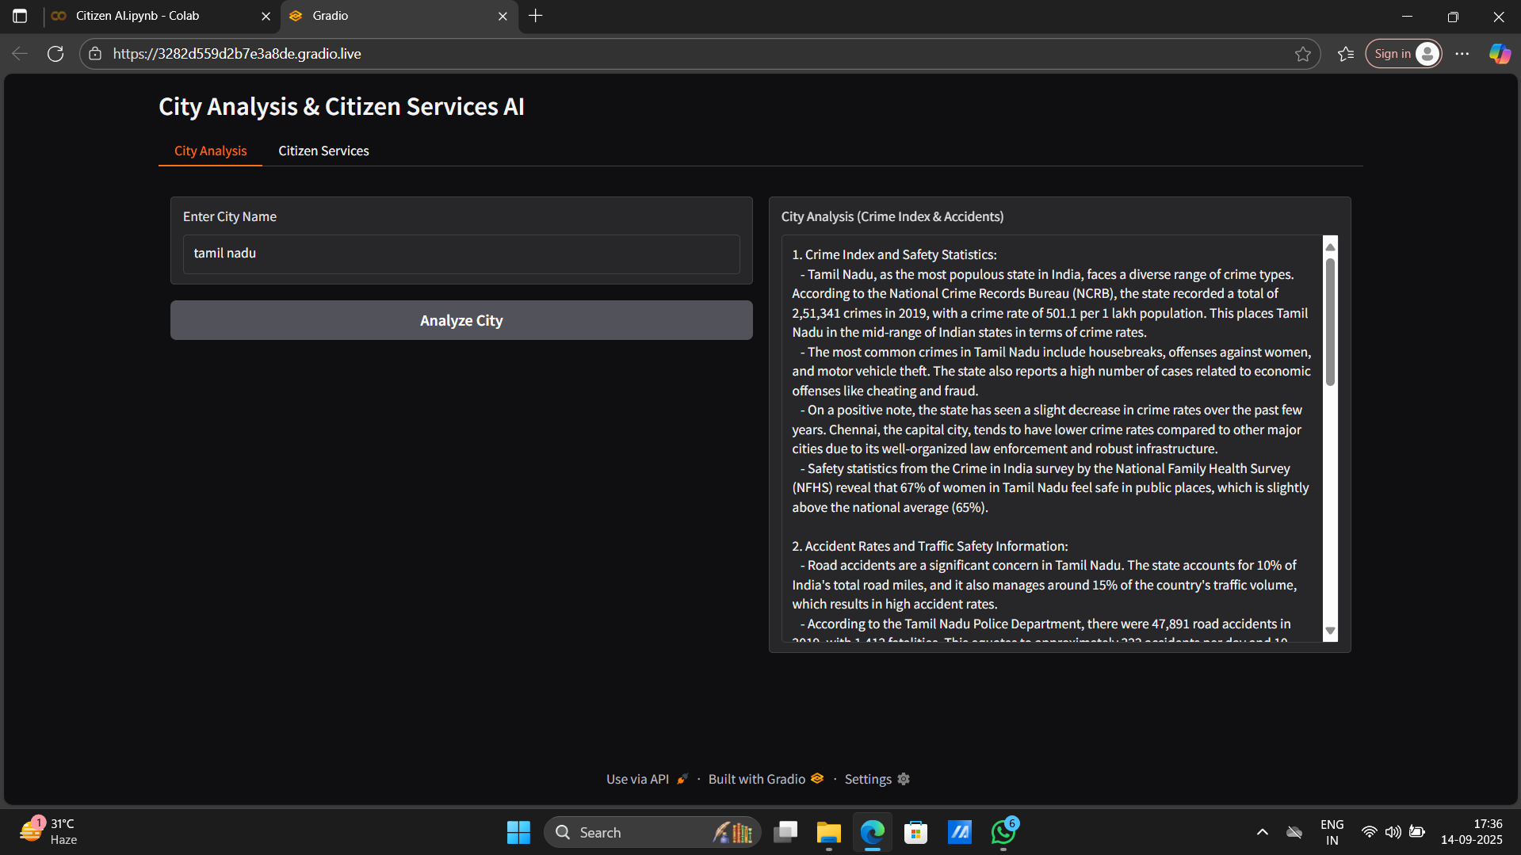

12.KNOWN ISSUES:

* Limited scope due to demo environment.
* Requires internet for colab runtime and Hugging face model.

13.FUTURE ENHANCEMENTS:

* Integrate advanced analytics for deeper insights.
* Expand support for multiple languages.
* Deploy on cloud platforms forreal world scalability.